North American Animal Disease Spread Model
Version 3.0

User’s Guide

April 26, 2006

Disease Simulation Model Team

Ashley Hill and Aaron Reeves

Copyright © 2005 - 2006 Animal Population Health Institute at Colorado State University.
Permission is granted to copy, distribute and/or modify this document under the terms of the Creative Commons Attribution-NonCommercial-ShareAlike 2.5 License. A copy of the license is included in the section entitled Creative Commons Public License.

Animal Population Health Institute
College of Veterinary Medicine & Biomedical Sciences
Colorado State University
Fort Collins, CO 80523
http://www.cvmbs.colostate.edu/aphi

Table of contents

Acknowledgements

Document conventions

1. Introduction to NAADSM

1.1. Purpose and uses
The North American Animal Disease Spread Model (NAADSM) simulates outbreaks of foot and mouth disease and other contagious animal diseases. As a training tool, NAADSM can be used to prepare emergency personnel and other first responders for disease outbreaks. NAADSM can also be used to demonstrate to policy makers the potential scope and impact of an outbreak in their region. As a research tool, NAADSM can be used to compare disease control strategies and estimate the resources needed in the event of an outbreak.
We do not recommend the use of NAADSM during an outbreak to predict direction and magnitude of disease spread, or during an outbreak as the basis for policy decisions. Information on disease incidence early in an outbreak is typically inaccurate. Simulated outbreaks based on inaccurate information will be useless, and may provide a false sense of security regarding the scope and control of the outbreak.

1.2. Capabilities
NAADSM is a flexible tool for simulating the temporal and spatial spread of foot and mouth disease and other contagious animal diseases at the herd level in a population of naïve animals. Users may use their own population data and adjust all parameters related to animal population, disease transmission, and disease control to closely mimic the situation in their region of interest. Users may also employ animal data and parameters provided with the program and which mimic the American Midwest, or can create their own randomly-distributed animal population data.

1.3. Limitations
NAADSM is not capable of simulating chronic, endemic, fatal, vertically-transmitted, sexually-transmitted, or vector-borne diseases; diseases with environmental or biologically-adapted reservoirs; or diseases that do not confer post-infection immunity.
As mentioned above, NAADSM is not intended to be used in the face of an outbreak to predict magnitude or direction of disease spread.

1.4. Overview of simulation parameters
Users should be familiar with the parameters described in the NAADSM model description (Appendix A). This appendix gives a complete, detailed list of all input parameters, and describes how each parameter is used in the course of a simulation. Input parameters apply to the following broad categories:
Animal populations. Herds may be classified based on user-defined production types. A production type is a collection of herds with similar disease transmission probabilities, disease manifestation, disease detection probabilities, and control strategies. The user defines the probability of airborne transmission and the rates of contact within and between production types to better mimic disease spread. Production types are typically defined by animal species and/or management practices applied to each herd. Production types may be broad (e.g. cattle, swine, poultry) or narrow (e.g. beef sale yard, beef cow-calf operation <50 head, beef cow-calf operation >50 head, beef feedlot).
Disease manifestation. There are five discrete disease states used in NAADSM. During a simulation, herds transition through these disease states according to the user-defined parameters. These states are susceptible to disease, latently infected, infectious and subclinically ill, infectious and clinically ill, and immune. For each production type, the user defines the length in days of all of these periods except the susceptible stage using probability distributions. All animals within a herd are assumed to exist in the same disease state.
Disease transmission. NAADSM was designed to simulate foot and mouth disease, but can be used to simulate any contagious animal disease that is spread primarily through aerosol transmission and/or direct and indirect contact. User-defined parameters define the probabilities of transmission via each method among and within production types.
Disease detection and surveillance. NAADSM allows the user to simulate both passive and active disease surveillance. Passive surveillance is a function of the length of time since the outbreak began and the length of time that a given herd has been infected. Active surveillance targets contacts from infected herds, and herds within a specified distance of infected herds.
Disease control. NAADSM simulates three methods of disease control: ring vaccination, movement restriction, and destruction. For each production type, the user defines the conditions under which these measures are adopted, the time to and length of vaccine-induced immunity, and the number of herds that can be vaccinated or destroyed per day. Vaccination is assumed to be 100% effective.
Direct costs. NAADSM can be used to estimate the direct costs associated with each simulated outbreak. User inputs include itemized costs associated with disease vaccination, and destruction.

1.5. Overview of simulation output
NAADSM provides results for single model iterations as well as summary results derived from multiple iterations. NAADSM generates a daily summary of each outbreak simulated, an epidemic curve, a breakdown of costs associated with the outbreak, and dozens of individual statistics (days to end of outbreak, number of herds and animals infected, number of herds and animals vaccinated, costs associated with vaccination, etc.). A complete description of all available model outputs is provided in Appendix B.
NAADSM summarizes the results over all iterations using histograms, measures of central tendency and spread, and graphical depictions of convergence.

2. System requirements
Several distinct but fully compatible and interchangeable versions of NAADSM are available. This guide is intended for users of NAADSM and Microsoft Windows. Additional information for users of advanced computational systems and environments is available in Appendix XX.
NAADSM is supported on Microsoft Windows ME, 2000, XP, and higher. At least 128 MB of RAM and 50 MB of available hard disk space are required. A faster computer with more memory will allow users to run larger and more sophisticated scenarios. The recommended system configuration for NAADSM is as follows: the equivalent of an Intel Pentium III or Pentium IV processor (or better), Windows 2000 or XP, 512 MB or more of RAM, and 150 MB of available hard disk space.

3. Basics of stochastic modeling
Biological processes display inherent variability. Take height, for example: height for human males can range from 5 to 7 feet (1.5 to 2.1 meters), although the average is close to 5 feet, 9 inches (1.77 meters) in the United States. If you were to develop a computer model to predict the amount of cloth needed to make some number of pairs of pants, and you needed to include human male height as a variable, you could do so in two ways. The first method would incorporate height as a single value, i.e. 5 feet 9 inches, and assume that all men are that height. This is called deterministic modeling, because the value of the variable height has already been determined. If you wanted to estimate the amount of fabric needed to make 1000 pairs of pants with a deterministic model, you would run the model once to calculate the amount of fabric needed for one pair, then multiply the results by 1000. Running the model additional times would not provide any new information: the input variable is fixed, and the result will be the same each time.
A second approach would be to incorporate height as a distribution of values representative of the natural range (see Figure 3-1, below). Now, if the model is run several times, and if a different value is drawn at random from this distribution for each run, the results will be slightly different each time. This is a stochastic model (stochastic is defined as “being or having a random variable”) because height is no longer a fixed value, but is drawn randomly from a distribution. Values with higher probability of occurring (i.e. heights close to 5’9”) are more likely to be drawn than values at the extreme ends (“tails”) of the distribution. In Figure 3-1, we can see that values below 1.61 meters (5’3”) are drawn 5% of the time, and values above 1.93 meters (6’4”) are drawn 5% of the time. Thus, 90% of the time, the value of height will be between 5’3” and 6’4” (1.61 and 1.93 meters).
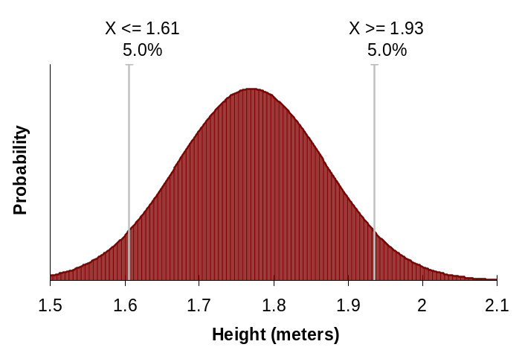
Figure 3-1. Distribution of height among males in the United States.
In a stochastic model, both the inputs and the outputs are distributions. Running the stochastic model from our example once is not particularly informative. However, by running the model 1000 times (running 1000 “iterations”), we get 1000 different estimates of the fabric needed for one pair of pants. These estimates form a distribution (Figure 3-2). To estimate the fabric needed for 1000 pairs of pants, we can sum the 1000 estimates. Results of stochastic models incorporate variability, whereas results from deterministic models do not. We can improve our model by incorporating additional stochastic variables, such as variability in the amount of fabric used per inch of height (which is be affected by waist size and pants style).
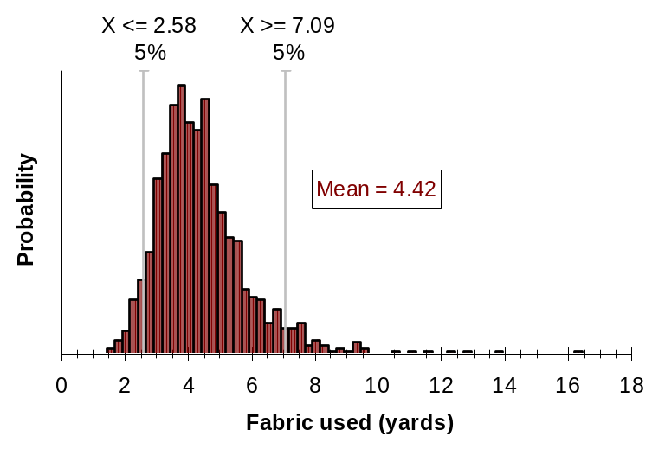
Figure 3-2. Output of 1000 iterations of a stochastic model estimating the amount of fabric needed to make a pair of pants.
NAADSM is a stochastic model. Variability is incorporated in the model using distributions, and relationships. A distribution is used when the variability in a parameter is assumed to be random. The distribution describes the range of values a variable can take, and how likely those values are to be selected. Model parameters described as distributions include the length of infectious period and the distance that animals are likely to be transported. A relationship is used when the variability in one parameter is due to another factor. A relationship describes one variable as a function of another (Figure 3-3). Model parameters described as relationships include the probability of detecting an infectious herd (which is a function of time since the herd was infected), and number of herds that can be depopulated per day (a function of time since the outbreak was detected).
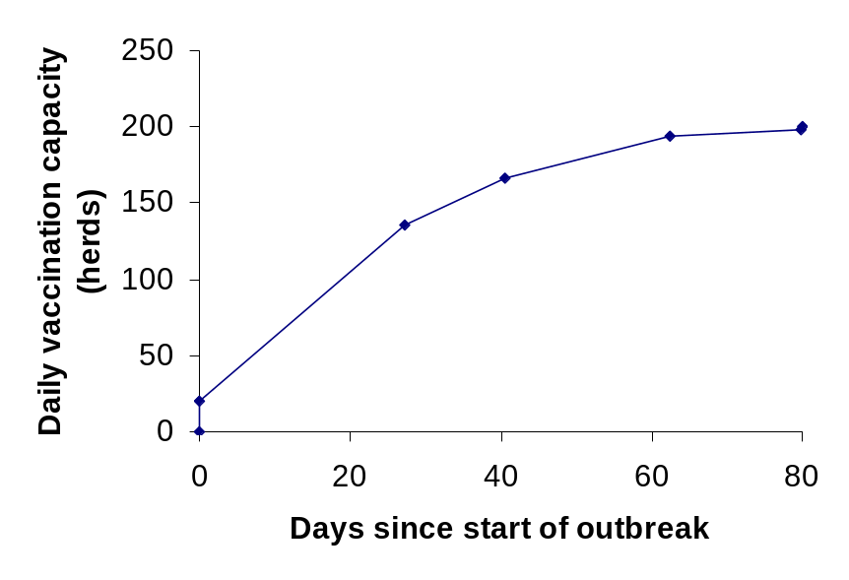
Figure 3-3. Number of herds that can be vaccinated per day as a function of time since the start of an outbreak.

4. Installing NAADSM
Installation of NAADSM should be straight-forward, and takes only one or two steps. First, obtain the most recent full installation package for NAADSM. The full installation package will have a file name similar to NAADSMSetup-3_0_x.exe, where the more recent full installation version number is given in place of “x”. Run this setup package, e.g., by double-clicking on its icon. A screen like the one shown in Figure 4-1 should be displayed.
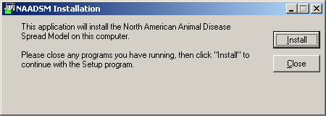
Figure 4-1. The first installation message displayed by the NAADSM setup package.
Click Install to begin the installation process. On the following screen, click
I agree to accept the license agreement. The NAADSM application and related library files will be installed to the folder C:\Program Files\NAADSM on your computer. If installation proceeds properly, the message shown in Figure 4-2 will be shown. (If an installation error occurs, please consult with one of the NAADSM developers, listed in Appendix XX).
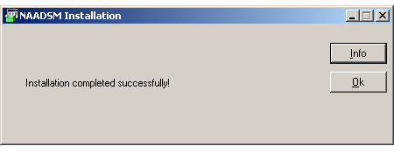
Figure 4-2. The final installation message displayed by the NAADSM setup package.

Once a full installation is complete, check for the availability of an NAADSM update package. Update packages will have file names similar to NAADSMUpdater-3_0_x.exe, and are used to update the one or two files that have changed since the last full installation version. If there are several update packages newer than your full installation, it is only necessary to obtain and run the newest update package. If successfully run, the update package will display messages as shown in Figure 4-3. If an update error occurs, please consult with one of the NAADSM developers.

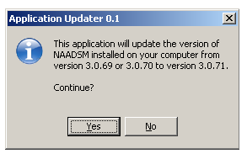 | 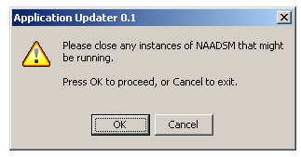
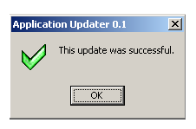
Figure 4-3. Messages displayed by the NAADSM update package.
When installation is complete, an NAADSM menu item will be added to your Windows Start menu, as shown in Figure 4-4. Select this item to launch NAADSM.
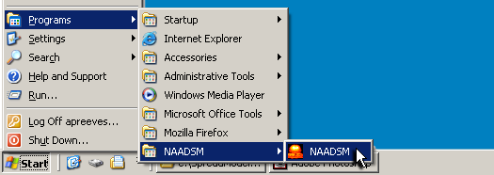

Figure 4-4. The NAADSM icon created on the Windows Start menu (the arrangement of your menu will vary).

5. Running your first simulation
NAADSM is supplied with a sample scenario, which includes herd population data and preset parameters representative of the American Midwest. To view and run this sample scenario, start the NAADSM application, go to the File menu, choose New scenario…, and then select Sample US Midwest scenario.
You should now see a map of herds, with latitude and longitude coordinates, on your screen. Note that nearly all dots on the map are black: these indicate herds that are susceptible to disease. Looking carefully, you will note a single yellow dot on the map. This represents a latently infected herd, which will be the source of infection for the simulated outbreak.
To review the parameters for this scenario, go to the Scenario parameters menu and choose Start setup. NAADSM parameters are specified with a series of “wizard” screens. By clicking on the Next > button on any of these screens, you may review these parameters in sequence. Alternatively, you may select one of the other items from uppermost section of the Scenario parameters menu to skip directly to the parameters of interest (Figure 5-1). Click the Finish button on any wizard screen when you are done reviewing the model parameters. (These wizard screens are discussed in greater detail in section XX below.)
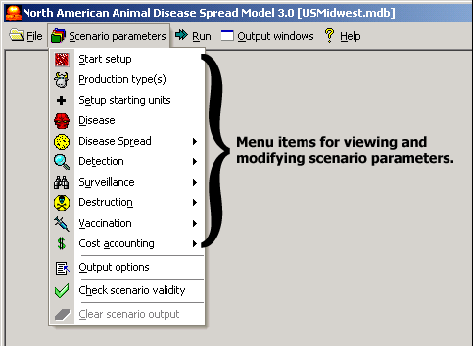

Figure 5-1. Menu items for viewing scenario parameters.

After selecting Start setup, the START SETUP screen will be displayed. In the box labeled Number of Iterations, type “1”. In the box labeled Random number generator seed, make sure that the option Generate seed automatically is selected. Click Finish to save your changes and exit the input wizard screen.
To start the simulation, go to the Run menu, and select Start and run until end of outbreak(s). NAADSM will now run the simulation. On the map, the dots representing herds will change colors to indicate their disease states (Figure 5-2). Clicking on the Status button on the map will change the legend to show disease status from an emergency personnel standpoint. At the bottom of your screen, a counter tracks the iteration number, and the day of the outbreak. A single run (iteration) of this scenario can take some time, depending on population size and computer speed, to reach completion. If you want to stop the iteration prematurely, click on the Stop button in the lower right corner of your screen. NAADSM will finish the current simulation “day” and then stop.
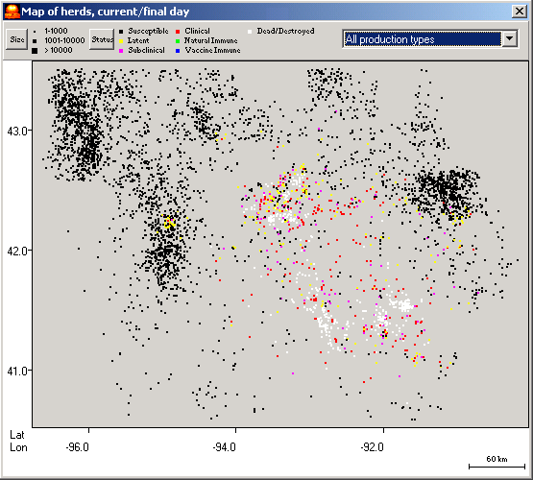

Figure 5-2. Map showing herds and their disease states for an iteration in progress. Points on the map will change color as herds are infected and transition through the defined disease stages. Color codes: black: susceptible herds; yellow: latently infected herds; pink: subclinically infected herds; red: infected herds showing clinical signs; white: herds that have been destroyed as a control measure in the simulation.

After the simulation stops (either on its own or as a result of using the Stop button), go to the Output windows menu and choose Summary of 1 iteration. This window shows the number of diseased herds and animals that were detected, and the numbers herds and animals destroyed or vaccinated. Additionally, you can see the epidemic curve apparent to emergency management personnel, as well as the “true” actual epidemic curve, which includes undetected diseased herds.
To see how the numbers of herds in the various disease stages changed over the course of the iteration, select Output windows, → Daily unit status for 1 iteration. A graph similar to the one shown in Figure 5-3 will be displayed. Note in Figure 5-3 how the number of susceptible herds declines as the numbers of herds in the various disease stages and the number of destroyed herds increase over time.
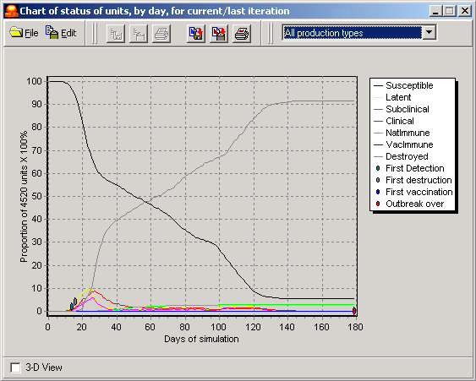

Figure 5-3. Chart showing the number of herds in the various disease stages over the course of a single iteration.
Several other selections are available on the Output windows menu. These items, which will be discussed in section XX below, are more useful when many iterations of a single scenario have been completed. The following sections of this guide will describe the kinds of parameters used to create or modify an NAADSM scenario, and will show how these parameters may be set by the user.

6. Input parameters
NAADSM accepts a multitude of parameters for scenario creation, which are discussed in detail in Appendix A. Many of these parameters are required; others are optional, depending on the particular details associated with each possible scenario. This section provides an overview of the types of parameters required to set up or alter an NAADSM scenario. All input parameters and their uses are described in detail in Appendix A, the model description document.

6.1. Basic types
There are six basic types of parameters used throughout NAADSM: yes/no values, integer values, floating point numbers, probabilities, probability density functions, and relational functions. The user interface provides hints as to which type of value is required for each parameter, and will not allow users to enter the wrong type.
These basic types are the building blocks of more complex elements of a complete NAADSM scenario, which will be examined in section 6.2.

6.1.1. Yes/no values
Many scenario settings in NAADSM may be switched on or off: for example, a scenario may be set up with vaccination as a control measure, or without vaccination as a control measure. Yes/no values (sometimes called true/false or boolean values) like this are usually set via check boxes: a check in the box indicates that the option will be enabled.

6.1.2. Integer values
Various parameters require whole number values: examples include the delay in whole days before a destruction campaign is initiated, and the number of diseased herds that must be detected before a vaccination program begins. The user interface will not allow negative or floating point numbers in fields that require integers.

6.1.3. Floating point numbers
Floating point (sometimes called real) numbers are values such as 1, 2.6, 9.34, etc. Several input parameters, such as the mean rate of herd shipments, are floating point numbers. Latitude and longitude are expressed as floating point numbers as well.

6.1.4. Probabilities
Quite a few model parameters are specified as probabilities, or floating point values between 0 and 1. An example is the probability of infection given exposure to an infected herd. The user interface will not allow users to enter values outside of the range between 0 and 1 when a probability is required.

6.1.5. Probability density functions
Probability density functions (pdfs) are distributions of values representative of the natural range of possible values for some parameter. The length of time that an infected herd is clinically infectious is one of many pdf parameters required by NAADSM. Values are drawn stochastically from these distributions as a simulation runs. Section 3 (Basics of stochastic modeling) provides additional background information regarding the use of pdfs.

6.1.5.1. Creating and editing pdfs
A new pdf may be created by entering parameters for a known mathematical probability function (normal, uniform, lognormal, triangular, etc.), by importing data, or by using the provided tools to create your own shape. Appendix XX lists the known mathematical pdf types supported by NAADSM.

6.1.5.1.1. The pdf selection box
Each pdf parameter in NAADSM is associated with a selection box like the one shown in Figure 6-1. The selection box shows a list of pdfs defined in each scenario, and provides buttons for editing, creating, and removing pdfs.
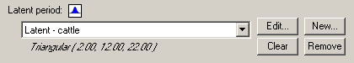

Figure 6-1. Selection box for probability density functions. Use the drop-down box to select a pdf that has already been defined. Click Edit… to alter an existing pdf, or New… to define a new pdf. Note that a description of the selected pdf is displayed below the drop-down box.

6.1.5.1.2. The pdf editor window
Clicking on either the Edit… or New… button will bring up a pdf editor window, similar to the one shown in Figure 6-2. The left side of the window shows the type of the selected pdf (e.g. triangular, normal, uniform, piecewise, etc.), the parameters required to define the selected type, and the values of those parameters. The right side of the window graphically depicts the selected pdf. Changing the parameters will cause the graphical depiction to change as well (Figure 6-3). If the parameters are changed to inappropriate values, an error message is displayed (Figure 6-4). The user must address the error problem in order to save the changes to the newly altered or created pdf.
Every new pdf must be assigned a unique name. Enter the name in the Function name text box in the upper right corner of the pdf editor window (Figure 6-2). If you are editing an existing pdf, you may rename it by changing the name entered in the Function name text box.
Once you have created or edited a pdf, you need to save it to apply the changes that you have made. This may be accomplished in either of two ways: you can use the File→Save changes to function and exit menu command or click on the button.
If you wish to exit the pdf editor window without applying the changes you have made, use the File→Exit without saving changes menu command or click on the button.

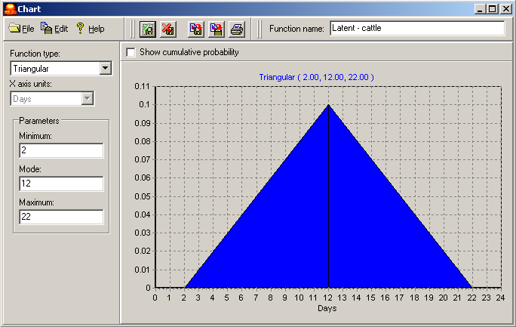

Figure 6-2. The pdf editor window. The type and parameters for the selected pdf are shown on the left. A graphical preview of the pdf is shown on the right. Note the name assigned to this particular pdf, shown in the upper right corner.

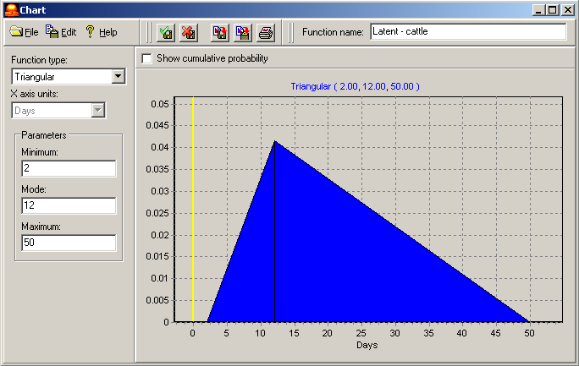

Figure 6-3. The parameters of the triangular pdf have changed. The graphical preview has been updated to correspond to the new parameters.

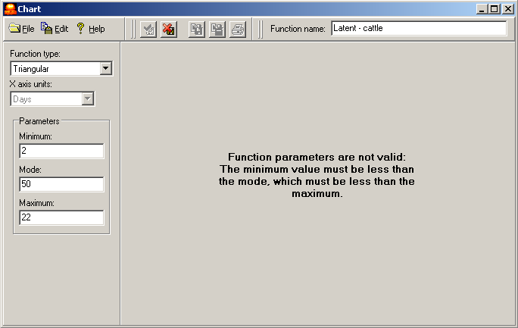

Figure 6-4. There is an error in the specified parameters. The source of the error is shown instead of the graphical preview.

6.1.5.1.3. Creating and editing piecewise pdfs
Piecewise pdfs can reflect nearly any shape that the user wishes, provided that the start and end points have an y value of 0. Figure 6-5 shows a piecewise pdf in the pdf editor window.
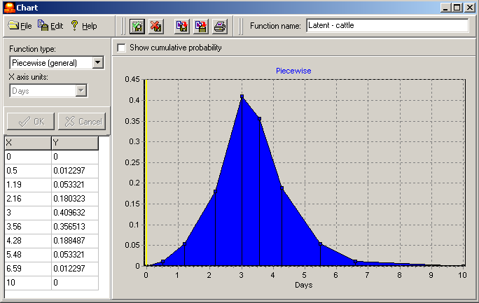

Figure 6-5. A piecewise pdf. The x and y values of each individual point are shown in the left panel. A graphical preview is shown on the right.
To create piecewise pdf, select Piecewise (general) from the list of function types. Three points are created automatically (Figure 6-6). You can alter the shape by moving or deleting existing points, or by adding new points. NAADSM will standardize the pdf so that the area under the curve is always 1. If you are editing an existing piecewise pdf, Piecewise (general) will already be selected, and the currently defined points will be displayed.
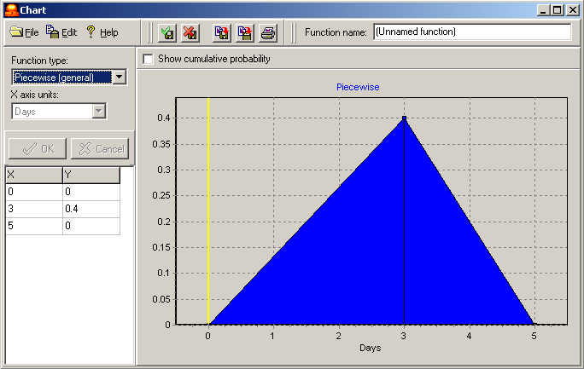

Figure 6-6. A new piecewise pdf. Three points are created by default. The values of these points may be changed directly in the left panel. Points may be added, removed, or dragged to new positions in the right panel. Note that the newly created function is unnamed. The user should assign a unique name to each new pdf.

Adding a new point
Move your pointer to a location on the chart where you would like an additional point. Right-click, then select Add point (Figure 6-7).

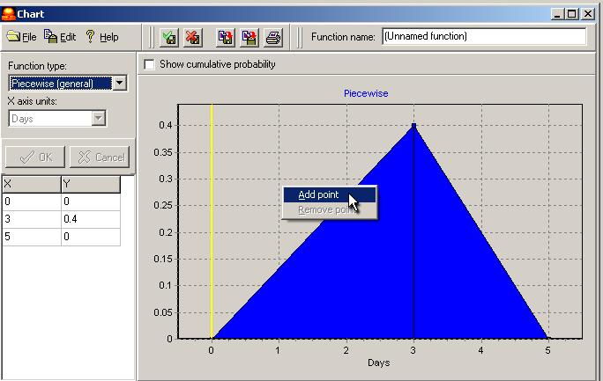

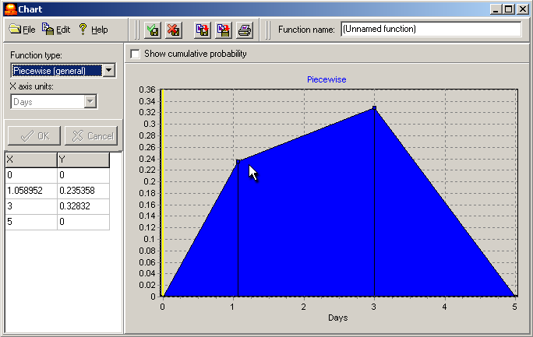

Figure 6-7. Adding a new point to a piecewise pdf. Right-click on the image to bring up the context menu, and select Add point (top panel). The new point will be added in the location where the click occurred (lower panel). Note that the y values in the left panel are automatically standardized to give a total area under the curve of 1.

Moving an existing point
Left click on the point you wish to move. While holding the mouse button down, drag the point to its new position (Figure 6-8).
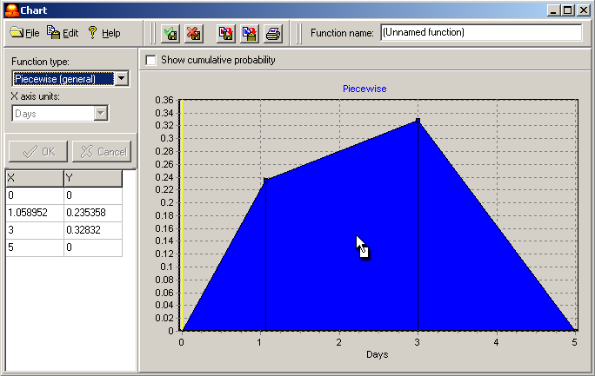

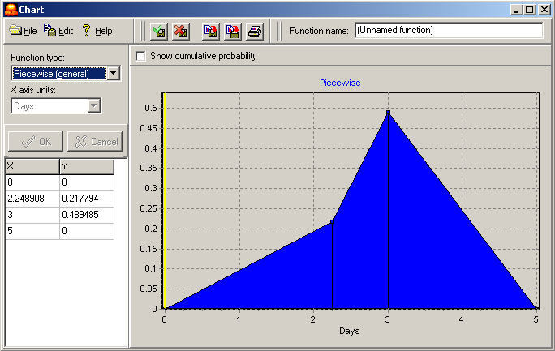

Figure 6-8. Moving an existing point of a piecewise pdf. Left click on a point, and while holding the mouse button down, drag the point to its new location (top panel). When the mouse button is released, the point will move to the new position (lower panel). Note that the x and y values in the left panel are updated to show the new position.

Changing the x-axis
To increase the maximum value of the x axis, click on the rightmost point of your distribution, and drag it towards the right. When you lift your finger from the mouse button, the x axis will be rescaled. Similarly, to decrease the maximum value of the x axis, click on the rightmost point of your distribution, and drag it to the left. The same techniques can be used to alter the minimum value visible on the x axis.
The x axis can be altered with more precision by directly editing the point values, as described below.

Deleting an existing point
Right-click on the point you wish to delete, and select Remove point.

Directly editing point values
The x and y coordinates of each point (displayed in the left panel of the pdf editor window) may be changed directly by editing the values shown in the left panel. Simply enter the desired values, and click on the OK button to apply your changes.
There are several things to note when point values are edited directly: first, the leftmost and rightmost points must always have a y value of 0: attempts to assign these values to something other than 0 will not be successful. Second, the y values are automatically rescaled to give a graph with a total area of 1. If you change a y value, it will immediately be rescaled once you apply the changes so that it is appropriately proportional to the other values in the graph. If you need to adjust several y values, make all of your changes before clicking on the OK button to prevent immediate rescaling of each y value as you enter it.

6.1.5.1.4. Importing a piecewise pdf
If you have defined values for your piecewise pdf in another application (for example, in a spreadsheet or a statistical package), you may import the point values directly into the pdf editor window. Data should consist of two columns (x and y values) and should be in a comma-separated (*.csv ) file. Values along the x axis should be in units appropriate for the pdf (for example, the x axis should be in days for a pdf describing the length of the latent period). Values along the y axis are in units of probability density such that the area under the curve of the entire function equals 1. NAADSM will adjust y axis values as needed to ensure that the area under the curve equals 1. Data can be imported from a file or from the clipboard. Figure 6-9 shows sample data suitable for importing into the pdf editor window. More detail about the proper file format for this and other files used by NAADSM is given in Appendix C.
To import points from a file, use the menu command File→Import points from file… in the pdf editor window. To import points from the clipboard, use the menu command Edit→Import points from clipboard. Do not forget to assign a name to your new pdf in the Function name text box in upper right corner of the pdf editor window. Save the new pdf as usual, using either the File→Save changes to function and exit command or the button.

x, y
0, 0
0.5, 0.012198
1.19, 0.052892
2.16, 0.178874
2.72, 0.349649
3, 0.406341
3.56, 0.353648
4.28, 0.186973
5.48, 0.052892
6.59, 0.012198
10, 0

Figure 6-9. A properly formatted CSV file for importing a piecewise pdf function. Note that the first row is a header row, which identifies the x and y columns. (Columns shown here are evenly spaced to make them easier to read: uniform spacing is not required in the file to be imported.)

6.1.5.2. Exporting a piecewise pdf
You may want to export the coordinates a pdf. Exporting coordinates may be useful if you want to re-create the pdf in other software (e.g. in Excel), or if you want to import the pdf for use in another variable (for example, you may want to use the same pdf for both latent and infectious subclinical periods). You can export the points of a piecewise pdf to a file, or to the clipboard for pasting into another application.
To export to a file, use the File→Export points to file… menu command, and enter the name of a comma-delimited (*.csv) file to save. To export (copy) points to the clipboard, simply use the Edit→Copy points to clipboard menu command.

6.1.5.3. Saving, copying, or printing pdf images
The graphical image of any pdf may be saved to a file, copied to the clipboard, or printed.
Images are saved in the Windows metafile (*.wmf) format. To save a pdf image, use the menu command File→Save chart image… in the pdf editor window and enter a valid file name. Alternatively, you may use the button.
To copy a pdf image to the clipboard, use the menu command Edit→Copy chart image to clipboard or use the button. The copied image is suitable for pasting into Microsoft Word, PowerPoint, and many other applications.
To print a pdf image, use the menu command File→Print chart image… and select a printer. Alternatively, you may use the button to print the image directly to the currently selected system printer.

6.1.6. Relational functions
Relationships or relational functions (sometimes referred to as rels in NAADSM) are used in situations where one variable is a function of another: an example of a rel in NAADSM is the probability of detecting an infectious herd, which is a function of time since that herd itself was infected (see section 3 and Figure 3-3 for a more detailed discussion of rels). In NAADSM, rels are created, edited, and handled in ways very similar to those described for pdfs (see section 6.1.5).

6.1.6.1. The rel selection box
Each rel parameter in NAADSM is associated with a selection box like the one shown in Figure 6-10. The selection box shows a list of rels defined in each scenario, and provides buttons for editing, creating, and removing rels.
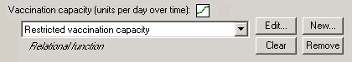

Figure 6-10. Selection box for relational functions. Use the drop-down box to select a rel that has already been defined. Click Edit… to alter an existing rel, or New… to define a new rel.

6.1.6.2. The rel editor window
Clicking on either the Edit… or New… button will bring up a rel editor window, similar to the one shown in Figure 6-11.
The right side of the window graphically depicts the selected rel. Changing the parameters will cause the graphical depiction to change as well. If the parameters are changed to inappropriate values, an error message is displayed. The user must address the error problem in order to save the changes to the newly altered or created rel.
Every new rel must be assigned a unique name. Enter the name in the Function name text box in the upper right corner of the rel editor window (Figure 6-11). If you are editing an existing rel, you may rename it by changing the name entered in the Function name text box.
Once you have created or edited a rel, you need to save it to apply the changes that you have made. This may be accomplished in either of two ways: you can use the File→Save changes to function and exit menu command or click on the button.
If you wish to exit the rel editor window without applying the changes you have made, use the File→Exit without saving changes menu command or click on the button.

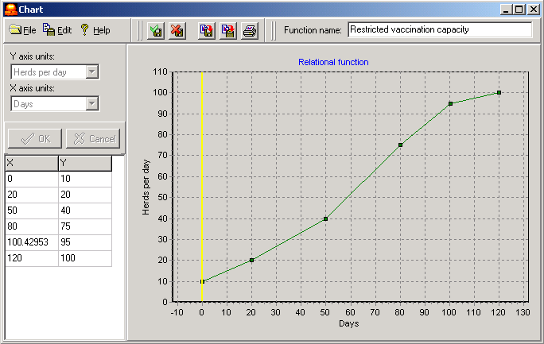

Figure 6-11. The rel editor window. The values of each point are displayed in the left panel. A graphical preview of the rel is shown on the right. Note the name assigned to this particular rel, shown in the upper right corner.

6.1.6.3. Creating and editing rel functions
Relational functions can reflect nearly any shape that the user wishes. When a new rel function is created, three points are created automatically (Figure 6-12). If you are editing an existing rel function, currently defined points will be displayed. You can alter the shape by moving or deleting existing points, or by adding new points.

Adding a new point
New points are added to rels in the same way that they are added to piecewise pdfs. Move your pointer to a location on the chart where you would like an additional point. Right-click, then select Add point.

Moving an existing point
Left click on the point you wish to move. While holding the mouse button down, drag the point to its new position.

Changing the axes
To increase the maximum value of either axis, click on the uppermost (for the y axis) or the rightmost (for the x axis) point of your function, and drag it toward the top (for the y axis) or the right (for the x axis). When you lift your finger from the mouse button, the axis will be rescaled. Similarly, to decrease the maximum values, drag points downward or to the left. The same techniques can be used to alter the minimum value visible on either axis.
The axes can be altered with more precision by directly editing the point values, as described below.
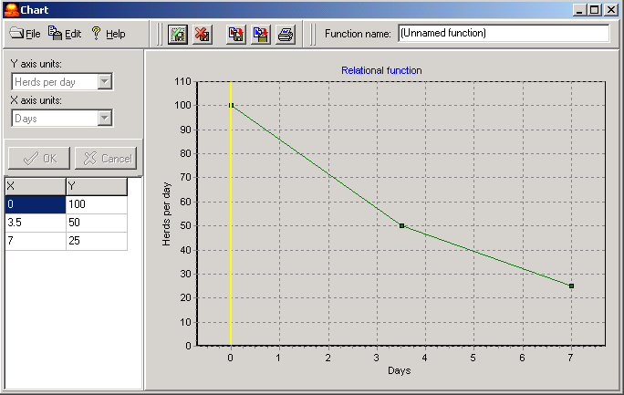

Figure 6-12. A new relational function. Three points are created by default. The values of these points may be changed directly in the left panel. Points may be added, removed, or dragged to new positions in the right panel. Note that the newly created function is unnamed. The user should assign a unique name to each new rel.

Deleting an existing point
Right-click on the point you wish to delete, and select Remove point.

Directly editing point values
The x and y coordinates of each point (displayed in the left panel of the rel editor window) may be changed directly by editing the values shown in the left panel. Simply enter the desired values, and click on the OK button to apply your changes.

6.1.6.4. Importing a rel function
If you have defined values for your relational function in another application (for example, in a spreadsheet or a statistical package), you may import the point values directly into the rel editor window. Data should consist of two columns (x and y values) and should be in a comma-separated (*.csv ) file. Values along the x axis should be in units appropriate for the rel. Data can be imported from a file or from the clipboard. Figure 6-13 shows sample data suitable for importing into the rel editor window. More detail about the proper file format for this and other files used by NAADSM is given in Appendix C.
To import points from a file, use the menu command File→Import points from file… in the rel editor window. To import points from the clipboard, use the menu command Edit→Import points from clipboard. Do not forget to assign a name to your new rel in the Function name text box in upper right corner of the rel editor window. Save the new rel as usual, using either the File→Save changes to function and exit command or the button.
x, y
0, 10
20, 20
50, 40
80, 75
100, 95
120, 100

Figure 6-13. A properly formatted CSV file for importing a relational function. Note that the first row is a header row, which identifies the x and y columns. (Columns shown here are evenly spaced to make them easier to read: uniform spacing is not required in the file to be imported.)

6.1.6.5. Exporting a rel function
You may want to export the coordinates a rel. Exporting coordinates may be useful if you want to re-create the rel in other software (e.g. in Excel), or if you want to import the rel for use in another variable. You can export the points of a piecewise rel to a file, or to the clipboard for pasting into another application.
To export to a file, use the File→Export points to file… menu command, and enter the name of a comma-delimited (*.csv) file to save. To export (copy) points to the clipboard, simply use the Edit→Copy points to clipboard menu command.

6.1.6.6. Saving, copying, or printing images of rel functions
The graphical image of any rel may be saved to a file, copied to the clipboard, or printed.
Images are saved in the Windows metafile (*.wmf) format. To save a rel image, use the menu command File→Save chart image… in the rel editor window and enter a valid file name. Alternatively, you may use the button.
To copy a rel image to the clipboard, use the menu command Edit→Copy chart image to clipboard or use the button. The copied image is suitable for pasting into Microsoft Word, PowerPoint, and many other applications.
To print a rel image, use the menu command File→Print chart image… and select a printer. Alternatively, you may use the button to print the image directly to the currently selected system printer.

6.2. Complex types

6.2.1. Herds or units
The smallest unit in an NAADSM scenario is a herd (recall that NAADSM simulates disease at the herd level, rather than at the level of the individual animal). Within NAADSM, the more generic term “unit” is used instead of “herd” to refer to a collection of animals.
Each unit has the following attributes, which must be specified by the user:
- Geolocation, specified by latitude and longitude
- Number of animals in the unit (unit size)
- Production type (see section 6.2.2)
- Initial disease state
As described in Appendix A (Description of the NAADSM conceptual model), there are five disease states, as well as two more possible unit states that act like disease states. These are as follows:
- Susceptible to infection
- Latent
- Infectious but not showing clinical signs of disease
- Infectious and showing clinical signs
- Naturally immune to infection
- Vaccine immune to infection
- Destroyed
If a unit is not specifically assigned an initial disease state, it is assumed to be susceptible to disease. Units are susceptible indefinitely: there is no fixed time period for the susceptible state. Units cease to be susceptible upon infection. There is also no fixed time period for units in the destroyed state: once a unit has been destroyed in a particular iteration, it is never “repopulated” during that iteration, and remains in the destroyed state.
The remaining five stages are associated with a determinate (but randomly determined) time period. The length of time each unit spends in these stages is based on the probability density functions for these stages for the unit’s given production type. See Appendix A and section 6.2.2 for more information.

6.2.2. Production types
Every unit in a simulation has a particular production type. Production types are typically based on animal species and/or management practices applied to particular types of livestock operations. For example, beef cattle would likely be a separate production type from swine, since the biological activity of most diseases will be different in cattle than in swine. Beef cattle might also be a separate production type from dairy cattle: although the disease dynamics may be quite similar within one species, very different management practices may influence the detection or spread of disease. Users may define as few or as many production types as they wish.
Production types from the basis for many parameters in an NAADSM scenario. Each production type has the following attributes:
- Duration of the latent, subclinical, clinical, and naturally immune disease stages (probability density functions: see section 6.1.5)
- Duration of the vaccine immune stage (a probability density function: see section 6.1.5)
- Detection and surveillance parameters, some of which are relational functions (see section 6.1.6)
- Control (vaccination and destruction) measures, some of which are relational functions (see section 6.1.6)
- Direct costs associated with control measures

6.2.3. Production type combinations
Disease is spread from one unit to another based on contact rates and probabilities of disease transfer, which are set for each pair of production types. The spread of disease from cattle to cattle, for example, may involve a much higher contact rate than spread from cattle to swine. Similarly, the probability of disease transfer from swine to cattle may be different from the probability of transfer from cattle to swine.
All disease spread parameters are set for each pair of production types in a scenario. Spread may occur between some or all of these production type pairs.

6.2.4. Control resource restrictions
The application of some control measures may be resource-limited: in the face of a large outbreak, for example, it may not be possible to vaccinate or destroy all new cases immediately. Destruction and vaccination capacity are specified as global resource restrictions: these capacities apply across units of all production types. These capacities are specified as relational functions (see section 6.1.6), so they may be set to change over time.

7. Basic file operations: File menu commands
The File menu includes tools for managing scenario files, as well as the means to create, open, and save files. Scenario files are saved as Microsoft Access-compatible files. These files store all information included in a scenario, such as the geolocation, size, and production type of each herd; the disease spread and control parameters for each production type; and output generated by simulating the scenario.
NOTE: (for advanced users and developers)

An NAADSM scenario file may be opened and viewed with any application capable of opening Microsoft Access databases, such as Microsoft Access itself, a utility like JetSQLConsole (<http://www.reevesdigital.com/jetsqlconsole>), or a custom script or application. Other applications, for example, might use output generated by NAADSM for analyses not built into NAADSM. Because all of this data is available in a commonly used format, data import or export from or to other sources should be relatively simple.

A complete description of the NAADSM database schema is provided in Appendix D.

7.1. New scenario file
The File → New scenario file command has two options: Empty scenario creates a completely empty scenario file: the user must enter all disease and control parameter values, and must import or create an animal population to which these parameters apply. The second option, US Midwest scenario, creates

7.2. Open scenario file…

7.3. Export scenario…

7.4. Save scenario file

7.5. Save as…

7.6. Close scenario file

7.7 Exit

New scenario
Open scenario
This option opens an existing scenario file.
Import scenario
(??? SHARCSpread XML)
Export scenario
(??? SHARCSpread XML)
Save scenario
Use this menu item to save the current scenario with any changes that you have made or results that may have been generated.
Save as
This option saves the current scenario under a different name. Parameterizing and populating a scenario from scratch is time-consuming: in most cases, it is more efficient to open an existing scenario, alter parameters as necessary, and save the scenario under a different file name.
Tools
Repair/compact database. Microsoft Access files increase in size each time they are used. This increase in size, although due primarily to empty space, can slow the operation of NAADSM . By using this menu item, you can streamline NAADSM operation and minimize the hard disk space required for the current scenario file. (Under normal circumstances, use of this menu item is not required, since NAADSM will automatically repair and compact database files as needed.)
SQL tool. This tool for advanced users enables use of SQL (structured query language).
Append output. Not currently implemented. This will allow (I think!) output from a new series of iterations to be added to, rather than replace, output from previous iterations using the same scenario.
Remove temporary files. (not sure about this!) If your computer crashes or is shut down in the midst of a simulation, temporary files created during the simulation will remain on your computer. Use this option to remove those files.
Exit
Shuts down the NAADSM application.

Setup/Parameters menu
Options in this menu allow you to create or modify an animal population, specify parameters for disease spread and control, select optional output data, and enter costs associated with disease and disease control. After selecting Start setup, clicking on the Next button will take you sequentially through all basic setup options. Alternatively, you can select setup options individually from the menu.
Start setup
In this window, you enter a text description of your scenario, specify the number of times you want to run the scenario, and select whether you want the model to run stochastically or deterministically.
Number of iterations establishes how many times you want to run the scenario. The more iterations you run, the better distribution of results you obtain. You can then better determine which results occur commonly, and which are unusual. The current standard in stochastic modeling is 100 – 10,000 iterations, though that range may be impractical for large or complex data sets. Ten iterations may be a good starting point.
Random values specifies whether NAADSM runs stochastically or deterministically. For stochastic modeling, select Generated during run. For deterministic modeling, select Use a fixed value, then enter a number between 0 and 1 in the Fixed value box. The fixed value you enter specifies which value will be chosen from each distribution. For example, if your fixed value is 0.5, NAADSM will select the median value (50th percentile) from each distribution it uses, whereas if your fixed value is 0.75, NAADSM will select the value at the 75th percentile.
Output settings
You can select additional NAADSM outputs here. Requesting additional output will slow the operation of NAADSM .
Events by day creates a dataset including … (not sure what this does).
GIS output. When this option is selected, NAADSM will create spatial output datasets readable by GIS (graphical information systems) software. Under Export dataset to GIS system, choose how frequently (during the simulated outbreak) GIS data should be output, keeping in mind that each export uses computational resources. Your selection of File format will depend on the import options available in your GIS software. Use the Browse button to select the location and filename of your GIS export file.
Production type(s)
Use this window to create (Add), rename (Modify), or Remove production types, which are groups of herds. A production type defines a group of herds with similar disease transmission probabilities, disease manifestation, disease detection probabilities, and control strategy. Production types can be broad (e.g. cattle, swine, poultry) or narrow (e.g. Beef sale yard, beef cow-calf operation <50 head, beef cow-calf operation >50 head, beef feedlot). NAADSM can incorporate up to 99 user-defined production types. All herds must have a production type.
Setup starting units
Use this section to import, create, or edit your animal population data.
Add units randomly positioned in a circle. Select this option if you have no animal population data, or if you want to add herds to your existing population. Click on the Next button to generate animal population data.
Definition of main circle for location of added units allows you to specify the geolocation (Latitude and Longitude) and Radius of your circle. If adding to an existing population, the latitude and longitude should be within your existing region. Latitude values range from -90 to +90, whereas longitude values range from -180 to +180 degrees. Proportion of units should be 1, unless you also want to create clusters of herds within your circle.
Randomly distributed clusters of smaller circles within the main circle. This option allows you to include multiple smaller clusters of herds within your circle. All clusters will be the same size if more than one is included. These may mimic dense unit areas within a general population. To activate this option, enter a value less than 1 for Proportion of units under Definition of main circle. The total proportion of units for the main circle and the randomly distributed clusters will add up to 1. Specify the size (Radius) and Number of clusters to include. Clusters are smaller circles that will be randomly distributed within the general circle.
Use the Production type table to specify herd size ranges for each production type, as well as the relative proportions for each production type. For each production type, enter the percentage of herds (Proportion) belonging to that production type. To specify herd size range for a production type, click the appropriate row under Size of units, then click the View chart button. A window displaying the probability density function (distribution) for herd size will open. Instructions for “Creating and modifying a probability density function” can be found in the User’s Guide on page ???. Click the Close button to return to the previous window.
Number of units to add. Specify the total number of herds you wish to add in your main circle (and clusters).
Click the Finish button to complete your creation of new herds.
Import units from a text file. Select this option if you have your own herd data. To be successfully imported into NAADSM , your data must include herd ID, production type, herd size, and latitude and longitude for each herd. The data must have a filename ending in .txt or .csv, be comma delimited, and be ordered as follows: herd ID, production type, herd size, latitude, longitude. Production type and herd ID should both have numeric values, not text. Importing will not succeed if data is missing for one or more herds. Recommendations for dealing with incomplete data can be found in the User’s Guide under “Using your own data”. If your data fits these restrictions, click Next, then select your data file and click Open.
You should now see a preview of your imported data.
Next to Notes, you can see the text values assigned to your numeric production type codes. You cannot change the text assignment at this time, though you can do so after importation by renaming the production type. The User’s Guide section on “Production type(s)” describes this.
Current number of units tells you how many herds your scenario has, not including the herds you are about to import.
Number of units in the previewed data tells you how many herds are in the data you are about to import.
Click Next when you are done reviewing your data.
You will be asked whether you want to Delete current units before creating additional units. If you want your scenario to include only the herds from the data you are about to import, click Yes. If you want your scenario to include the herds already in the scenario, plus the herds from the data you are about to import, click No. You will be asked to confirm your choice. Click Yes.
The number of herds (units) imported will be reported. Click Finish.
View/edit existing starting units. Select this option to see or edit data on herds included in your scenario. Editable data include herd size, production type, geolocation, and infection status. All imported units are initially assigned to the susceptible disease state. In order for a simulated outbreak to occur, at least one herd in your data must be designated as latent, subclinically shedding, or infectious. To change infection status, click on the Status cell for the appropriate herd. Click again, and a drop-down menu will become available for the cell. Select the appropriate infection status. When done editing the data, click the ✓ button then Save to save your edits, or click Cancel to exit without changing the data. Click the Finish button when done. Note: herds can also be infected randomly; this can be done by choosing Interactive/Advanced from the Setup/Parameters menu, then selecting the Infections tab.
Go to next section. Selecting this option and clicking Next will move you to the Disease option of the Setup/parameters menu.
Disease
Use this section to describe the duration of each disease stage (latent, infectious yet subclinical, infectious and clinical, and immune) for each production type. Select a production type, then adjust parameters as described below.
Transition the disease in units of this production type. Select this option if disease occurs in the production type. If the box is checked, the following variables will appear:
Latent period (in days). This variable is a probability density function (pdf) defining the duration of the latent period within the herd. Select an appropriate pdf from the drop-down menu, or create your own. See the User’s Guide section on “Creating and modifying a probability density function” for assistance with this.
Infectious subclinical period (in days). This variable is a probability density function (pdf) defining the duration of the period when the herd is infectious, yet not clinically ill. Select an appropriate pdf from the drop-down menu, or create your own. See the User’s Guide section on “Creating and modifying a probability density function” for assistance with this.
Infectious clinical period (in days). This variable is a probability density function (pdf) defining the duration of the period when the herd is clinically ill. Select an appropriate pdf from the drop-down menu, or create your own. See the User’s Guide section on “Creating and modifying a probability density function” for assistance with this.
Immune period after infection (in days). This variable is a probability density function (pdf) defining the duration of immunity following natural infection. Select an appropriate pdf from the drop-down menu, or create your own. See the User’s Guide section on “Creating and modifying a probability density function” for assistance with this.
After describing disease stage durations for a specific production type, click Save.
To apply disease stage settings from one production type to all other production types, highlight the production type with the settings you want, then click on the Copy parameters button. Click Yes to confirm your choice.
Surveillance
Use this section to adjust parameters associated with active and passive disease surveillance for each production type.
Yes, include surveillance/detection. When this option is selected, you can adjust parameters for active and passive surveillance within production types. Click Next to continue.
Conduct surveillance of this production type. When this option is selected for a given production type, then disease can be detected in that production type. Specific parameters can be adjusted as described below.
General population (scanning surveillance). Parameters in this section affect passive surveillance: the probability that infection will be noticed and reported to authorities. The likelihood that an infected herd will be detected depends on two time variables: how long the herd has been infected, and how long the outbreak has been going on.
Probability of reporting given the number of days the unit is infectious. This parameter describes the probability that an infected herd will be detected (reported) as a function of time since the herd became infected. Select an appropriate function (relationship) from the drop-down menu, or create your own. See the User’s Guide section on “Creating and modifying a function (relationship)” for assistance with this.
Probability of reporting given the day since first detected. This parameter describes the probability that an infected herd will be detected (reported) as a function of time since the outbreak was initially detected. Select an appropriate function (relationship) from the drop-down menu, or create your own. See the User’s Guide section on “Creating and modifying a function (relationship)” for assistance with this.
Ring/circle around affected unit (targeted surveillance). Parameters in this section affect active surveillance, specifically visiting herds within a certain distance of a herd known to be infected. If a herd’s disease state is “infectious clinical” at the time of the visit, then disease will be detected. If the herd’s disease state is “latent” or “infectious subclinical” at the time of the visit, then disease will not be detected (???). The number of herds visited per day within the ring is determined by ???.
Ring size in km. Enter the radius of your surveillance ring.
Number of surveillance visits to be declared uninfected. Enter the maximum number of visits received by each herd within the surveillance ring. If the herd has not been found infected in this number of visits, it will no longer be visited.
Direct trace with affected unit (targeted surveillance). Parameters in this section affect active surveillance, specifically tracing and visiting herds that have had direct contact with an infected herd (during its infectious period?).
Trace back success rate. The probability that a herd directly contacted by an infected herd is visited by emergency personnel. Enter a value between 0 (0%) and 1 (100%). ???Disease in the contact herd will be detected if the herd’s disease state is “infectious clinical”.
Indirect trace with affected unit (targeted surveillance). Parameters in this section affect active surveillance, specifically tracing and visiting herds that have had indirect contact with an infected herd (during its infectious period?).
Trace back success rate. The probability that a herd indirectly contacted by an infected herd is visited by emergency personnel. Enter a value between 0 (0%) and 1 (100%). ???Disease in the contact herd will be detected if the herd’s disease state is “infectious clinical”.
After adjusting surveillance parameters for a specific production type, click Save to make these changes permanent.
To apply surveillance settings from one production type to all other production types, highlight the production type with the settings you want, then click on the Copy parameters button. Click Yes to confirm your choice.
Click Finish when done.
No, do not include surveillance/detection. When this option is selected, the outbreak is never detected and runs its course without intervention. Click Finish when done.
Vaccination
Use this section to adjust parameters associated with vaccination within rings around infected herds.
Yes, include ring vaccination around detected units. Select this option to enable ring vaccination. Click Next to continue.
Vaccination starting point. Click Next when done.
Begin ring vaccination after detecting how many units of any production type? Ring vaccination is triggered when disease has been detected in a given number of herds (units). Enter a value of 1 or more.
Vaccination priorities. In an outbreak, resources and personnel at some point may not be able to keep up with demand for vaccination. Use this section to determine how vaccination is prioritized when demand cannot be met. Click Next when done.
Primary priorities. This frame lists broad categories for prioritizing vaccination. Items listed include production type, days holding, and reason for vaccination. Days holding is the number of days the herd has been waiting for vaccination. (??? What is interactive vaccination, and where does one turn it on/off and adjust settings???) Change priority order by dragging items up or down in the list.
Secondary priorities. This frame lists the options within the category selected under primary priorities. Change priority order by dragging items up or down in the list.
Priority examples for selections above. This frame shows the order in which herds will be vaccinated, based on your sequence of primary and secondary priorities.
Vaccination. Use this window to edit vaccination parameters specific to each production type. Select a production type, then edit parameters. Click Save to make your edits permanent.
Trigger a vaccination ring upon detection of disease in units of this production type. Check this box if you want detection of disease in this production type to deploy a vaccination ring.
Radius of vaccination ring (in km). Enter the radius of your vaccination ring.
Vaccinate units of this production type as part of ring vaccination efforts. Check this box if you want herds of this production type to be vaccinated. Vaccination is 100% effective if administered when the herd is susceptible, unless the herd is infected before the vaccine takes effect.
Immune period (in days). This variable is a probability density function (pdf) defining the duration of immunity following vaccination. Select an appropriate pdf from the drop-down menu, or create your own. See the User’s Guide section on “Creating and modifying a probability density function” for assistance with this.
Delay in immunity following vaccination (in days). This variable defines the number of days following vaccination that the herd remains susceptible.
Frequency of vaccination no more than every (in days). This variable defines how often a herd may be visited for vaccination. (not sure when this variable is used?)
Vaccination capacity. This variable describes the number of herds of this production type that can be vaccinated per day. The variable is a function of time (in days) since the outbreak was first detected (in any production type, right?). Select an appropriate function from the drop-down menu, or create your own. See the User’s Guide section on “Creating and modifying a function (relationship)” for assistance with this.
After defining vaccination settings for a specific production type, click Save.
To apply vaccination settings from one production type to all other production types, highlight the production type with the settings you want, then click on the Copy parameters button. Click Yes to confirm your choice.
Click Finish when done.
No, do not include vaccination. Select this option to disable ring vaccination. Click Finish when done.
Destruction
Use this section to adjust parameters associated with destruction/depopulation of infected or suspect herds.
Yes, include destruction of detected and associated herds. Select this option to enable herd destruction/depopulation. Click Next to continue.
Destruction starting point. Click Next when done.
After detection of the first case in any production type, begin destruction after how many days? Destruction/depopulation begins a given number of days after disease has been detected. Enter a value of 1 or more.
Destruction priorities. In an outbreak, resources and personnel at some point may not be able to keep up with demand for destruction/ depopulation. Use this section to determine how destruction is prioritized when demand cannot be met. Click Next when done.
Primary priorities. This frame lists broad categories for prioritizing destruction. Items listed include production type, days holding, and reason for destruction. Days holding is the number of days the herd has been listed for destruction. Reasons for destruction list different reasons a herd could have marked for destruction. These include having disease detected, having direct contact with an infected herd, having indirect contact with an infected herd, and being within a circle/ring around an infected herd. Change priority order by dragging items up or down in the list.
Secondary priorities. This frame lists the options within the category selected under primary priorities. Change priority order by dragging items up or down in the list.
Priority examples for selections above. This frame shows the order in which herds will be destroyed, based on your sequence of primary and secondary priorities.
Destruction. Use this window to edit destruction parameters specific to each production type. Select a production type, then edit parameters. Click Save to make your edits permanent.
Trigger pre-emptive destruction upon detection of disease in units of this production type. Check this box if you want detection of disease in this production type to trigger destruction.
Direct contact units. Check this box if herds directly contacted by an infected herd will be destroyed. All herds directly contacted by the infected herd within a given number of days before the infection was detected are potentially infected and eligible for destruction. Enter an appropriate number of days next to Contact-days before detection.
Indirect contact units. Check this box if herds indirectly contacted by an infected herd will be destroyed. All herds indirectly contacted by the infected herd within a given number of days before the infection was detected are potentially infected and eligible for destruction. Enter an appropriate number of days next to Contact-days before detection.
Within circle/ring units. Check this box if herds within a given distance of a known infected herd will be destroyed. In Radius for circle/ring, enter the radius (in kilometers) around an infected herd within which other herds will be destroyed.
After defining destruction settings for a specific production type, click Save.
To apply destruction settings from one production type to all other production types, highlight the production type with the settings you want, then click on the Copy parameters button. Click Yes to confirm your choice.
Click Finish when done.
No, do not include destruction. Select this option to disable herd destruction/depopulation. Click Finish when done.
Economics/cost
Use this section to enter monetary costs associated with the impact and control of the outbreak for each production type.
Yes, include costs/economics. Select this option to enable tracking of outbreak costs. Click Next to continue.
Track costs/economics of units of this production-type. Select a production type, then check this box to track its outbreak-associated costs. Click Save to make your edits permanent.
Destruction. Costs associated with herd destruction/depopulation are included in this section.
Cost appraisal/unit. Enter the cost of having an appraiser visit a herd and assess its value.
Cost euthanasia/animal. Enter the cost of euthanizing a single animal.
Cost indemnification/animal. ??? Not sure what this is ???
Cost carcass disposal/animal. Enter the cost of carcass disposal for a single animal.
Cost cleaning+disinfection/unit. Enter the cost of having a farm of this production type cleaned and disinfected.
Surveillance. Costs associated with active surveillance are included in this section.
Radius of surveillance zone. Enter a value in kilometers. The value should be the same as that entered during surveillance setup as Ring/circle around affected unit (targeted surveillance). See page ??? in the User’s Guide for additional information.
Cost diagnostic tests/unit. If diagnostic testing is a method used to detect disease in your scenario, enter the average cost of applying these tests to a herd of this production type.
# of surveillance visits/month/unit. Enter the average number of times a herd within a surveillance zone would be visited for disease detection.
Cost surveillance/visit/unit. Enter the cost associated with sending a surveillance team out to visit a herd. Do not include costs associated with testing the herd.
Vaccination. Costs associated with vaccination are included in this section.
Cost vaccination/site/unit. Enter the costs associated with sending a team out to vaccinate a herd. Do not include the costs of the vaccine itself.
Cost vaccine/animal. Enter the cost of administering the vaccine to a single animal of this production type.
Baseline vaccination capacity. Enter the number of ???herds, ???animals that can be vaccinated ???per day, ???during the outbreak. ???How does this differ from vaccination capacity entered during vaccination setup?
Cost additional vaccine/animal. ??? not sure what this is.
Net annual value exports affected. Enter the net annual value of exports of this production type that are likely to be affected by an outbreak and resulting trade restrictions.
# months to destroy vaccinates. Enter the number of months (after the end of the outbreak? after the time of vaccination?) it will take to destroy all vaccinated animals and thus re-establish disease-free status.
Resumption to normal trade. This variable describes post-outbreak animal trade in this production type as a proportion of pre-outbreak trade. The variable is a function of time (in days) since country was declared disease-free by the OIE. Select an appropriate function from the drop-down menu, or create your own. See the User’s Guide section on “Creating and modifying a function (relationship)” for assistance with this.
After entering cost/economic settings for a specific production type, click Save.
To apply economic settings from one production type to all other production types, highlight the production type with the settings you want, then click on the Copy parameters button. Click Yes to confirm your choice.
Click Finish when done.
No, do not include costs/economics. Select this option to disable tracking of outbreak costs. Click Finish when done.
Spread
Use this section to adjust parameters associated with spread of disease from infected herds of each production type.
What type of SPREAD would you like to model during simulation runs? Select whether you want NAADSM to simulate airborne spread, spread via contact with an infected herd, both airborne and contact spread, or no spread at all. Click Next when done, or Finish if you selected no spread.
Production-type combinations. Use this window to select which production types can spread disease to which other production types. For example, if one of your production types was “feedlot” and one was “beef cow-calf operation”, you may opt to allow disease to spread from a cow-calf operation to another cow-calf operation and from a cow-calf operation to a feedlot, but not from a feedlot to another feedlot. Be aware that the more production type combinations you use, the more memory NAADSM requires, and the more slowly it will operate. Click the Next button when done.
Production-type combinations. This frame shows which production type combinations are capable of disease spread. For example, in the listing “Production type 1 > Production type 2”, the source of disease is “Production type 1” and the destination is “Production type 2”. In other words, disease can be spread from “Production type 1” to “Production type 2” production type. To remove an item from this frame, select the item, then click the Remove button. Hold down the ctrl button to select multiple items. Items can be added to this frame using either Choose from all combinations, or Match production types below.
Choose from all combinations. This frame shows all possible combinations of your production types. To add an item from this frame to the Production-type combinations frame, select the item, then click the Add button. Hold down the ctrl button to select multiple items.
Match production types below. This area has two frames, each with a list of all your production types. Select a production type (in the left frame) from which disease can spread, and a production type (in the right frame) that can catch disease from the first production type you selected. Click on the Add button, and this production type combination will be added to your list.
Airborne. Use this window to modify parameters describing airborne spread of disease for each production type combination. Select a production type combination, then adjust parameters as described below.
Model airborne spread between these production types. Check this box to include airborne spread in this production type combination in your simulation. Click Next when done.
Probability spread/contg. day, at 1 km, average unit sizes. If you had one herd of each production type in your combination, and these herds were of average size and located 1 kilometer apart, and herd 1 was infected with disease, what is the probability that herd 2 would become infected within one day of herd 1 becoming contagious? Enter a value between 0 (0%) and 1 (100%).
Maximum distance spread under these conditions (in Km). If a herd was infected and shedding disease, how far from that herd can disease be spread via the air? The value must be an integer, and must be greater than one.
Range of wind direction. These parameters describe the directions in which disease can spread by air. Allowable range of wind direction is described by degrees (range: 0 to 359) The circle gives a visual representation of the range you specify: blue indicates wind, and grey indicates no wind. A range from 0 to 359 will color the entire circle blue. Smaller ranges (i.e. 30 to 180) will restrict wind direction and thus leave part of the circle grey.
After entering airborne settings for a specific production type combination, click Save.
To apply airborne disease spread settings from one production type combination to all other production type combinations, highlight the combination with the settings you want, then click on the Copy parameters button. Click Yes to confirm your choice.
Contact. Use this window to modify parameters describing direct and indirect contact spread of disease for each production type combination. Select a production type combination, then adjust parameters as described below.
Model direct contact spread between these production types. Check this box to include disease spread by direct contact in this production type combination in your simulation. Direct contact involves transferring one or more animals from one herd to another. Click Next when done.
Include latent units. Check this box if direct contact with a latently infected herd can spread disease.
Include subclinical shedding units. Check this box if direct contact with a subclinically affected herd that is shedding the disease agent can spread disease.
Mean rate (recipient units/unit/day). On average, how many herds of production type 2 does a herd of production type 1 directly contact each day? Enter a value.
Distance distribution of recipient units. This variable is a probability density function (pdf) defining the distance between a herd of production type 1, and its direct contacts of production type 2. Select an appropriate pdf from the drop-down menu, or create your own. See the User’s Guide section on “Creating and modifying a probability density function” for assistance with this.
Probability of infection transfer (if source positive). If a herd of production type 1 is infected, and it directly contacts a herd of production type 2, how likely is it that the contact herd will become infected? Enter a value between 0 (0%) and 1 (100%).
Model indirect contact spread (visitors, vehicles, etc). Check this box to include disease spread by indirect contact in this production type combination in your simulation. Indirect contact involves movement of animate or inanimate objects, such as people or vehicles, between herds. Click Next when done.
Mean rate (secondary contact units/unit/day). On average, how many herds of production type 2 does a herd of production type 1 indirectly contact each day? Enter a value.
Distance distribution of contact units. This variable is a probability density function (pdf) defining the distance between a herd of production type 1, and its indirect contacts of production type 2. Select an appropriate pdf from the drop-down menu, or create your own. See the User’s Guide section on “Creating and modifying a probability density function” for assistance with this.
Probability of infection transfer (if source positive). If a herd of production type 1 is infected, and it indirectly contacts a herd of production type 2, how likely is it that the contact herd will become infected? Enter a value between 0 (0%) and 1 (100%).
Effect of movement controls on rates, after detection in any production type. After detection of disease, movement of livestock may be restricted. Use this variable to estimate the effect of movement restrictions. This variable describes animal movement between these production types as a proportion of pre-outbreak animal movement, i.e. direct contact rate (or does it apply to both direct and indirect contact???). The variable is a function of time (in days) since disease was detected. Select an appropriate function from the drop-down menu, or create your own. See the User’s Guide section on “Creating and modifying a function (relationship)” for assistance with this.
After entering disease spread settings for a specific production type, click Save.
To apply disease spread settings from one production type to all other production types, highlight the production type with the settings you want, then click on the Copy parameters button. Click Yes to confirm your choice.
Click Finish when done.
Interactive/advanced
Options in this section allow you to randomly infect a specific number or proportion of herds, and to initiate vaccination or depopulation after interruption of a simulation. All parameters are production-type specific. Select a production type, then adjust parameters as described below.
Population. ???Not sure how this option differs from Add Units in a Circle option under Setup Starting Units???
Infection. Options on this tab allow you to increase or decrease the number of infected herds of a given production type.
Current number of incubating units. The number of herds of the selected production type that are latently infected (??? at the start of the simulation, or during the simulation???). This option is not currently functional.
Current number of contagious units. The number of herds of the selected production type that are either subclinically infected and contagious, or clinically ill. This option is not currently functional.
Clear infection. Click on this button to eliminate latent, subclinical, and clinical infection in all herds of this production type.
Infect units. Click this button to randomly infect herds using the specified parameters.
Number of units to infect randomly. Use this option to randomly infect either a specific number or a specific proportion of herds of this production type.
Increase the prevalence to. To randomly infect a proportion of herds of this production type, enter a number between 0 (0%) and 1 (100%).
Add a number of cases. To randomly infect a specific number of herds of this production type, enter a number greater than 0.
Infect as. Use this option to determine whether the herds being randomly infected are latently infected, or are contagious.
Incubating. Select this option to make randomly infected herds latently infected.
Contagious. Select this option to make randomly infected herds (???subclinically infected? Clinically infected?).
Destruction. Options on this tab allow you to change the number of depopulated herds of this production type. This tab may be used after interrupting a simulation to change the progression of the simulation. Note: to interrupt a simulation, go to the Run menu and choose Stop simulation.
Current number of destroyed units. The number of herds of the selected production type that have been destroyed so far in the simulation. This option is not currently functional.
Clear destroyed. Click this button to (???delete, or change back to last infection status???) depopulated herds of this production type.
Destroy now. Click this button to initiate destruction/depopulation of herds of this production type using specified parameters.
Contagious units. Check this box to initiate depopulation of (???subclinically and clinically infected, or just clinically infected???) herds of this production type. This box must be checked, or Destroy now will not function.
Within kilometers of contagious units. Check this box to initiate depopulation of herds within a specified distance of an infected (???subclinical as well as clinical??? Latent???). Enter an integer value for this distance (in kilometers).
Vaccination. Options on this tab allow you to change the number of vaccinated herds of this production type. This tab may be used after interrupting a simulation to change the progression of the simulation. Note: to interrupt a simulation, go to the Run menu and choose Stop simulation.
Current number of vaccinated units. The number of herds of the selected production type that have been vaccinated so far in the simulation. This option is not currently functional.
Current number of immune units. The number of herds of the selected production type that are (???naturally, or vaccinated???) immune so far in the simulation. This option is not currently functional.
Clear vaccination. Click this button to (???delete, or change back to last infection status???) vaccinated herds of this production type.
Vaccinate by increasing the proportion of units vaccinated. Enter the proportion (value between 0 and 1) of susceptible herds to be vaccinated, then click the Vaccinate randomly button.
Ring vaccinate around a location. Enter a latitude and longitude value for the location, as well as an integer value (in km) for the radius of the ring within which vaccination will take place, then click the Ring vaccinate button.
View current units
Use this option to view data on production type, herd size, location, disease status, and other disease-spread parameters for all herds in your data set. If you interrupt a simulation, these data reflect the situation in all herds as of the last simulated day. Click Finish when done. Note: data viewed is read-only; if you want to make changes to herd data, select Setup starting units from the Setup/parameters menu, then click View/edit existing starting units.

Run menu
Start or restart simulation run
Use this option to start your simulation from the beginning. You can choose the endpoint for the simulation using the options described below.
Stopping at the end of outbreak(s). Selecting this option will allow all iterations of the simulation to run until the outbreak is over, i.e. no herds remain infected, and no herds remain wait-listed for vaccination or destruction.
Stopping at first detection(s). Selecting this option will stop all iterations of the simulation on the day when infection is first detected in a herd of any production type.
Stopping at specified day. Selecting this option will stop all iterations of the simulation a specified number of days after the start of the iteration. Enter a value greater than 0, then click OK.
Continue current simulation run
Select this option if you have stopped your simulation, and wish to restart it in the same iteration, rather than starting over again from the beginning. When restarting, NAADSM will start from the last completed iteration; it will not pick up in the middle of an unfinished iteration. You can choose the endpoint for the simulation using the options described below.
Stopping at the end of outbreak(s). Selecting this option will allow all iterations of the simulation to run until the outbreak is over, i.e. no herds remain infected, and no herds remain wait-listed for vaccination or destruction.
Stopping at first detection(s). Selecting this option will stop all iterations of the simulation on the day when infection is first detected in a herd of any production type.
Stopping at specified day. Selecting this option will stop all iterations of the simulation a specified number of days after the start of the iteration. Enter a value greater than 0, then click OK.
Stop simulation
Select this option to stop the the simulation in the middle of the current iteration. The iteration will stop at the end of a simulated day; completing the day (and stopping the simulation) may take a minute or two depending on the complexity of the simulated situation.

Output/Windows menu
Map of units
This option opens a map with latitude and longitude coordinates displaying all herds. By default, this window opens when a scenario is opened. The map can display all herds, or only those of a particular production type. Herds can be coded by disease status, by herd size, or by method of exposure. Options are described below.
Size. This button toggles between displaying all herds identically, or indicating larger herds with larger blocks.
Status. This button toggles between displaying herds by disease status (susceptible, latent, subclinical and infectious, clinical and infectious, naturally immune, vaccine immune, and destroyed), and displaying herds by detection status and method of exposure (unknown, detected, slaughtered/destroyed, vaccinated, exposed via direct contact, exposed via indirect contact).
Production types. Use the drop-down menu to display only a specific production type on the map.
Charted status of units
This option opens a chart that displays the proportion of herds in various disease states over the length of an outbreak (in days). If your simulation included multiple iterations, only data from the last iteration will be displayed.
Copy. The leftmost button on the window. This option copies the chart to your clipboard in Windows metafile format.
Export. The middle button on the window. This option allows you to export the file and save it in Windows metafile (.wmf) format.
Print. This option sends the chart to the printer of your choice.
3-D view. Check this box to view the chart 3-dimensionally. This may be helpful when multiple disease states overlap.
Production types. Use this drop-down menu to modify the chart to show disease status in only one production type.
Outbreak statistics
This option displays a daily summary of the outbreak for each production type. Available data include the number of animals and herds in each disease state, by each method of exposure, and by implemented surveillance and control methods. Click on column titles to sort by that column; one click sorts in ascending order, a second click sorts in descending order, and a third click sorts the column by day (its original order). Double-clicking on column data will bring up a definition of the column.
In order from left to right, the buttons in the window perform the following functions:
⎮ This button moves you to the top of your selected column.
 This button moves you up one row in your selected column.
 This button moves you down one row in your selected column.
⎮ This button moves you to the bottom of your selected column.
 (??? Not sure what this does)
Copy. This option copies all highlighted rows to your clipboard in tab-delimited format.
Export. This option allows you to export all highlighted rows to a tab-delimited file and save it in ASCII text (.txt) format.
Search. Select this option to perform a text search of a particular column. (??? I couldn’t actually get this search function to do anything)
Move to match. Decide whether you want to search from the top of the column (First in column), downwards from the cell currently highlighted in the column (Down to next), or upwards from the currently highlighted cell (Up to prior).
Characters. Choose whether to search for your text string at the beginning of the cell (Match beginning of column), or can be anywhere in the column (Contained in column).
Enter characters. Enter the text to search for here.
Σ/ This button toggles between showing data from all days of every iteration, and showing only data from the last day of each iteration.
⬧ Displays help options relevant to this window.
Production types. Use this drop-down menu to show data for only one production type.
Cost of outbreak
(??? Not currently functional)
Contact-exposure events
This option displays all occasions on which a herd was exposed to disease, the day and method of exposure, the source herd, whether infection resulted, the production type of both the source and recipient herds, and whether tracing of the exposure was successful. If your simulation included multiple iterations, only data from the last iteration will be displayed.
In order from left to right, the buttons in the window perform the following functions:
⎮ This button moves you to the top of your selected column.
 This button moves you up one row in your selected column.
 This button moves you down one row in your selected column.
⎮ This button moves you to the bottom of your selected column.
 (??? Not sure what this does)
Copy. This option copies all highlighted rows to your clipboard in tab-delimited format.
Export. This option allows you to export all highlighted rows to a tab-delimited file and save it in ASCII text (.txt) format.
Search. Select this option to perform a text search of a particular column. (??? I couldn’t actually get this search function to do anything)
Move to match. Decide whether you want to search from the top of the column (First in column), downwards from the cell currently highlighted in the column (Down to next), or upwards from the currently highlighted cell (Up to prior).
Characters. Choose whether to search for your text string at the beginning of the cell (Match beginning of column), or can be anywhere in the column (Contained in column).
Enter characters. Enter the text to search for here.
Σ/ This button toggles between showing data from all days of every iteration, and showing only data from the last day of each iteration.
⬧ Displays help options relevant to this window.
Production types. Use this drop-down menu to show data for only one production type.
Apparent outbreak events
This option displays all occasions on which emergency personnel took action during the outbreak, what that action was (detecting disease, tracing infection, vaccination, destruction), the number of days into the outbreak that the action was taken, source and recipient herd IDs (where relevant) and production type, the herd size, and the number of days after herd infection that the action was taken. If your simulation included multiple iterations, only data from the last iteration will be displayed.
In order from left to right, the buttons in the window perform the following functions:
⎮ This button moves you to the top of your selected column.
 This button moves you up one row in your selected column.
 This button moves you down one row in your selected column.
⎮ This button moves you to the bottom of your selected column.
 (??? Not sure what this does)
Copy. This option copies all highlighted rows to your clipboard in tab-delimited format.
Export. This option allows you to export all highlighted rows to a tab-delimited file and save it in ASCII text (.txt) format.
Search. Select this option to perform a text search of a particular column. (??? I couldn’t actually get this search function to do anything)
Move to match. Decide whether you want to search from the top of the column (First in column), downwards from the cell currently highlighted in the column (Down to next), or upwards from the currently highlighted cell (Up to prior).
Characters. Choose whether to search for your text string at the beginning of the cell (Match beginning of column), or can be anywhere in the column (Contained in column).
Enter characters. Enter the text to search for here.
Σ/ This button toggles between showing data from all days of every iteration, and showing only data from the last day of each iteration.
⬧ Displays help options relevant to this window.
Production types. Use this drop-down menu to show data for only one production type.
Summary information
This option summarizes the number of herds and animals detected, destroyed, and vaccinated during the outbreak. The window also includes epidemic curves (both for all herds infected as well as only those detected by emergency personnel), and a breakdown of all infected herds and animals by method of infection. Data can be displayed for all production types, or for individual production types.
Copy. Charts and data are copied separately. After selecting copy, click Yes to copy only the epidemic curve charts, No to copy only the data, or Cancel to abort.
Export. Charts and data are exported separately. After selecting Export, click Yes to save charts (in Windows metafile (.wmf) format), No to save data in a tab-delimited text file, or Cancel to abort.
Production types. Use this drop-down menu to show data for only one production type.
Current/last iteration. Data from the most recent iteration of your simulation.
Surveillance. Check this box to see data on detection and tracing of infected herds, as well as visits to herds at risk of infection. All data is summarized at the herd and animal level.
Clinical detections. The number of herds (or animals) detected by passive surveillance, i.e. reporting by farmers.
Direct traces. The number of traces initiated based on direct contact with infected herds. In parentheses are the numbers of herds (or animals) successfully traced.
Indirect traces. The number of traces initiated based on indirect contact with infected herds. In parentheses are the numbers of herds (or animals) successfully traced.
Visits within ring. The number of visits made to herds (or animals) within a surveillance ring around an infected herd. In parentheses are ???
Destruction. Check this box to see data on reasons herds were destroyed.
Detection. The number of herds (or animals) destroyed because they were detected as being infected.
Direct traces. The number of herds (or animals) destroyed because they had direct contact with an infected herd.
Indirect traces. The number of herds (or animals) destroyed because they had indirect contact with an infected herd.
Circle. The number of herds (or animals) destroyed because they were within a specific distance of an infected herd.
TOTAL. The number of herds (or animals) destroyed in total.
Vaccination. Check this box to see data on reasons herds were vaccinated.
Ring. The number of herds (or animals) vaccinated because they were within a specified distance of an infected herd.
Interactive. The number of herds (or animals) vaccinated by using the Interactive/Advanced option under the Setup/Parameters menu.
TOTAL. The total number of herds (or animals) vaccinated.
Apparent epidemic curve. Check this box to see the epidemic curve observable to emergency personnel, i.e. the epidemic curve of all herds detected as infected by authorities. Time (in days) from the start of the simulation is on the x-axis, and number of newly infected herds (???) is on the y-axis.
Inapparent infection – reasons. Check this box to see a breakdown of all infected herds by method of infection.
Initially infected. The number of herds (or animals) infected prior to the start of the simulation.
Airborne. The number of herds (or animals) infected via airborne transmission.
Direct contact. The number of herds (or animals) infected via direct contact with an infected herd.
Indirect contact. The number of herds (or animals) infected via indirect contact with an infected herd.
TOTAL. The total number of herds (or animals) infected in the iteration.
Inapparent epidemic curve. Check this box to see the true epidemic curve of all infected herds: those missed by authorities as well as those detected. Time (in days) from the start of the simulation is on the x-axis, and number of newly infected herds (???) is on the y-axis.
Summary of iterations. Data summarized over all iterations. Not currently implemented.

Help menu
About this program. Indicates the version of the software, and methods of contacting the software team.

Appendix 1. File formats
Comma-delimited herd (unit) lists
XML herd lists
Scenario database structure
XML parameter files: refer to U. of G. website

Additional topics I’d like to get to, but haven’t yet…

Use as a training tool
Using your own data
Parameters needed (i.e. herd sizes, locations, production types, etc.)
Format for import (i.e. MS Access, variable names, etc.)
Disease parameters (disease stages)
Transmission parameters (aerosol, contact rates)
Disease detection options
Disease control options
NAADSM outputs
Statistical analysis
Interpretation
FAQs
All my iterations have identical results
No disease outbreak develops
Out of memory error
Infected herds are not destroyed or vaccinated
Index

Appendix X
NAADSM/SC, Linux, parallel computing systems

NAADSM/PC includes a complete graphical user interface for use with Microsoft Windows. NAADSM/SC (which does not include a graphical interface) works with various Unix/Linux versions and derivatives, including Mac OS X. Precisely the same core conceptual model is used in these two versions.

, designated NAADSM/PC and NAADSM/SC,

Scenario development is best performed using the graphical interface of the Windows version of NAADSM. Once parameters have been defined, they can be exported to the Linux/Unix version. Parameter input files for the two versions are fully interchangeable (see Appendix 1, File Formats, for more information).

Windows/PC requirements. At a minimum, the following are required to use NAADSM PC: Microsoft Windows 95 or greater (??? Which older operating systems require MDAC?),.
Windows installation. (??? Write this, once we have an installer package) (??? Include MDAC on the installation CD)

Linux/Unix requirements and installation. Please contact us. (??? Flesh this out a bit more)
The Unix/Linux version may be accessed via a web-based interface (if properly configured), or may be launched as a command line tool. Either version may be run on a stand-alone machine, or on a grid of networked computers. Both versions offer built-in support for Message Passing Interface (MPI)-based grid, cluster, or parallel computing systems. Additionally, the Windows version is compatible with Atriplex (http://www.atriplex.org), a simple grid system for taking advantage of the unused resources of typical office computers. An average stand-alone PC will comfortably accomodate 100 iterations of a simulation involving up to roughly 20,000 herds (such a simulation might take between roughly 10 minutes and 2 hours to run to completion). Simulations involving more than 30,000 herds and 200 iterations are better run on the MPI- or Atriplex-based grid systems..

Appendix XX. Supported PDFs

The Normal distribution is a bell-shaped curve described by two parameters: the mean, and the standard deviation. The Uniform distribution is a rectangular block, indicating that all values within a range occur with equal frequency; it is described by two parameters: the minimum and maximum of the range. The Lognormal distribution is a logarithmic transformation of the normal distribution; it is described using the same parameters as the normal distribution: mean and standard deviation. The Triangular distribution is, as its name implies, a triangle; it is described by three parameters: the minimum, peak (“most likely”), and maximum values.
The Normal and Uniform distributions are inherently symmetric. The Triangular distribution can be symmetric or asymmetric depending on the relation of the peak to the minimum and maximum values. The Lognormal distribution is extremely asymmetric (skewed to the right) when the mean is close to 0; the further the mean is from 0, the more the Lognormal distribution approaches the symmetry and shape of a Normal distribution.
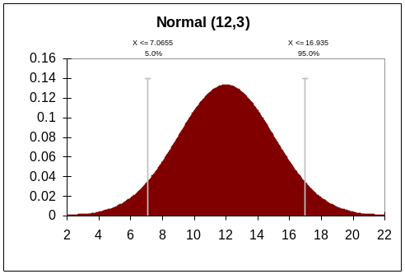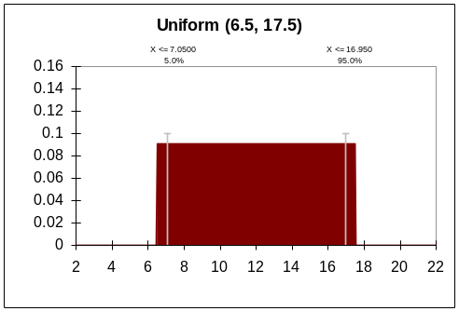
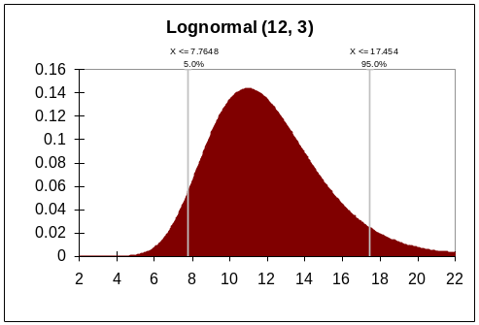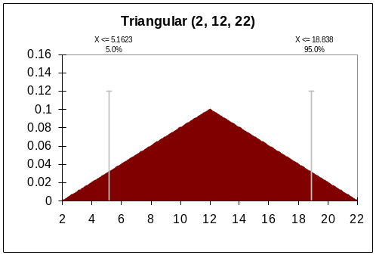
Figure 4. Normal, Uniform, Lognormal, and Triangular probability distributions.

Creative Commons Public License

General terms of the Attribution-NonCommercial-ShareAlike 2.5 license

Permission is granted to copy, distribute, display, and/or to make derivative works of this document, under the following conditions: the work must be attributed in the manner specified by the author or licensor; the work may not be used for commercial purposes; and any derived works may be distributed only under a license identical to this one.

Creative Commons web site

The Creative Commons web site is <http://creativecommons.org>.

More information regarding the Attribution-NonCommercial-ShareAlike 2.5 license
is available at <http://creativecommons.org/licenses/by-nc-sa/2.5>.

Legal code of the Attribution-NonCommercial-ShareAlike 2.5 license
License
THE WORK (AS DEFINED BELOW) IS PROVIDED UNDER THE TERMS OF THIS CREATIVE COMMONS PUBLIC LICENSE ("CCPL" OR "LICENSE"). THE WORK IS PROTECTED BY COPYRIGHT AND/OR OTHER APPLICABLE LAW. ANY USE OF THE WORK OTHER THAN AS AUTHORIZED UNDER THIS LICENSE OR COPYRIGHT LAW IS PROHIBITED.
BY EXERCISING ANY RIGHTS TO THE WORK PROVIDED HERE, YOU ACCEPT AND AGREE TO BE BOUND BY THE TERMS OF THIS LICENSE. THE LICENSOR GRANTS YOU THE RIGHTS CONTAINED HERE IN CONSIDERATION OF YOUR ACCEPTANCE OF SUCH TERMS AND CONDITIONS.
1. Definitions
- "Collective Work" means a work, such as a periodical issue, anthology or encyclopedia, in which the Work in its entirety in unmodified form, along with a number of other contributions, constituting separate and independent works in themselves, are assembled into a collective whole. A work that constitutes a Collective Work will not be considered a Derivative Work (as defined below) for the purposes of this License.
- "Derivative Work" means a work based upon the Work or upon the Work and other pre-existing works, such as a translation, musical arrangement, dramatization, fictionalization, motion picture version, sound recording, art reproduction, abridgment, condensation, or any other form in which the Work may be recast, transformed, or adapted, except that a work that constitutes a Collective Work will not be considered a Derivative Work for the purpose of this License. For the avoidance of doubt, where the Work is a musical composition or sound recording, the synchronization of the Work in timed-relation with a moving image ("synching") will be considered a Derivative Work for the purpose of this License.
- "Licensor" means the individual or entity that offers the Work under the terms of this License.
- "Original Author" means the individual or entity who created the Work.
- "Work" means the copyrightable work of authorship offered under the terms of this License.
- "You" means an individual or entity exercising rights under this License who has not previously violated the terms of this License with respect to the Work, or who has received express permission from the Licensor to exercise rights under this License despite a previous violation.
- "License Elements" means the following high-level license attributes as selected by Licensor and indicated in the title of this License: Attribution, Noncommercial, ShareAlike.
2. Fair Use Rights. Nothing in this license is intended to reduce, limit, or restrict any rights arising from fair use, first sale or other limitations on the exclusive rights of the copyright owner under copyright law or other applicable laws.
3. License Grant. Subject to the terms and conditions of this License, Licensor hereby grants You a worldwide, royalty-free, non-exclusive, perpetual (for the duration of the applicable copyright) license to exercise the rights in the Work as stated below:
- to reproduce the Work, to incorporate the Work into one or more Collective Works, and to reproduce the Work as incorporated in the Collective Works;
- to create and reproduce Derivative Works;
- to distribute copies or phonorecords of, display publicly, perform publicly, and perform publicly by means of a digital audio transmission the Work including as incorporated in Collective Works;
- to distribute copies or phonorecords of, display publicly, perform publicly, and perform publicly by means of a digital audio transmission Derivative Works;
The above rights may be exercised in all media and formats whether now known or hereafter devised. The above rights include the right to make such modifications as are technically necessary to exercise the rights in other media and formats. All rights not expressly granted by Licensor are hereby reserved, including but not limited to the rights set forth in Sections 4(e) and 4(f).
4. Restrictions.The license granted in Section 3 above is expressly made subject to and limited by the following restrictions:
- You may distribute, publicly display, publicly perform, or publicly digitally perform the Work only under the terms of this License, and You must include a copy of, or the Uniform Resource Identifier for, this License with every copy or phonorecord of the Work You distribute, publicly display, publicly perform, or publicly digitally perform. You may not offer or impose any terms on the Work that alter or restrict the terms of this License or the recipients' exercise of the rights granted hereunder. You may not sublicense the Work. You must keep intact all notices that refer to this License and to the disclaimer of warranties. You may not distribute, publicly display, publicly perform, or publicly digitally perform the Work with any technological measures that control access or use of the Work in a manner inconsistent with the terms of this License Agreement. The above applies to the Work as incorporated in a Collective Work, but this does not require the Collective Work apart from the Work itself to be made subject to the terms of this License. If You create a Collective Work, upon notice from any Licensor You must, to the extent practicable, remove from the Collective Work any credit as required by clause 4(d), as requested. If You create a Derivative Work, upon notice from any Licensor You must, to the extent practicable, remove from the Derivative Work any credit as required by clause 4(d), as requested.
- You may distribute, publicly display, publicly perform, or publicly digitally perform a Derivative Work only under the terms of this License, a later version of this License with the same License Elements as this License, or a Creative Commons iCommons license that contains the same License Elements as this License (e.g. Attribution-NonCommercial-ShareAlike 2.5 Japan). You must include a copy of, or the Uniform Resource Identifier for, this License or other license specified in the previous sentence with every copy or phonorecord of each Derivative Work You distribute, publicly display, publicly perform, or publicly digitally perform. You may not offer or impose any terms on the Derivative Works that alter or restrict the terms of this License or the recipients' exercise of the rights granted hereunder, and You must keep intact all notices that refer to this License and to the disclaimer of warranties. You may not distribute, publicly display, publicly perform, or publicly digitally perform the Derivative Work with any technological measures that control access or use of the Work in a manner inconsistent with the terms of this License Agreement. The above applies to the Derivative Work as incorporated in a Collective Work, but this does not require the Collective Work apart from the Derivative Work itself to be made subject to the terms of this License.
- You may not exercise any of the rights granted to You in Section 3 above in any manner that is primarily intended for or directed toward commercial advantage or private monetary compensation. The exchange of the Work for other copyrighted works by means of digital file-sharing or otherwise shall not be considered to be intended for or directed toward commercial advantage or private monetary compensation, provided there is no payment of any monetary compensation in connection with the exchange of copyrighted works.
- If you distribute, publicly display, publicly perform, or publicly digitally perform the Work or any Derivative Works or Collective Works, You must keep intact all copyright notices for the Work and provide, reasonable to the medium or means You are utilizing: (i) the name of the Original Author (or pseudonym, if applicable) if supplied, and/or (ii) if the Original Author and/or Licensor designate another party or parties (e.g. a sponsor institute, publishing entity, journal) for attribution in Licensor's copyright notice, terms of service or by other reasonable means, the name of such party or parties; the title of the Work if supplied; to the extent reasonably practicable, the Uniform Resource Identifier, if any, that Licensor specifies to be associated with the Work, unless such URI does not refer to the copyright notice or licensing information for the Work; and in the case of a Derivative Work, a credit identifying the use of the Work in the Derivative Work (e.g., "French translation of the Work by Original Author," or "Screenplay based on original Work by Original Author"). Such credit may be implemented in any reasonable manner; provided, however, that in the case of a Derivative Work or Collective Work, at a minimum such credit will appear where any other comparable authorship credit appears and in a manner at least as prominent as such other comparable authorship credit.
- For the avoidance of doubt, where the Work is a musical composition:
  - Performance Royalties Under Blanket Licenses. Licensor reserves the exclusive right to collect, whether individually or via a performance rights society (e.g. ASCAP, BMI, SESAC), royalties for the public performance or public digital performance (e.g. webcast) of the Work if that performance is primarily intended for or directed toward commercial advantage or private monetary compensation.
  - Mechanical Rights and Statutory Royalties. Licensor reserves the exclusive right to collect, whether individually or via a music rights agency or designated agent (e.g. Harry Fox Agency), royalties for any phonorecord You create from the Work ("cover version") and distribute, subject to the compulsory license created by 17 USC Section 115 of the US Copyright Act (or the equivalent in other jurisdictions), if Your distribution of such cover version is primarily intended for or directed toward commercial advantage or private monetary compensation.
- Webcasting Rights and Statutory Royalties. For the avoidance of doubt, where the Work is a sound recording, Licensor reserves the exclusive right to collect, whether individually or via a performance-rights society (e.g. SoundExchange), royalties for the public digital performance (e.g. webcast) of the Work, subject to the compulsory license created by 17 USC Section 114 of the US Copyright Act (or the equivalent in other jurisdictions), if Your public digital performance is primarily intended for or directed toward commercial advantage or private monetary compensation.
5. Representations, Warranties and Disclaimer
UNLESS OTHERWISE MUTUALLY AGREED TO BY THE PARTIES IN WRITING, LICENSOR OFFERS THE WORK AS-IS AND MAKES NO REPRESENTATIONS OR WARRANTIES OF ANY KIND CONCERNING THE WORK, EXPRESS, IMPLIED, STATUTORY OR OTHERWISE, INCLUDING, WITHOUT LIMITATION, WARRANTIES OF TITLE, MERCHANTIBILITY, FITNESS FOR A PARTICULAR PURPOSE, NONINFRINGEMENT, OR THE ABSENCE OF LATENT OR OTHER DEFECTS, ACCURACY, OR THE PRESENCE OF ABSENCE OF ERRORS, WHETHER OR NOT DISCOVERABLE. SOME JURISDICTIONS DO NOT ALLOW THE EXCLUSION OF IMPLIED WARRANTIES, SO SUCH EXCLUSION MAY NOT APPLY TO YOU.
6. Limitation on Liability. EXCEPT TO THE EXTENT REQUIRED BY APPLICABLE LAW, IN NO EVENT WILL LICENSOR BE LIABLE TO YOU ON ANY LEGAL THEORY FOR ANY SPECIAL, INCIDENTAL, CONSEQUENTIAL, PUNITIVE OR EXEMPLARY DAMAGES ARISING OUT OF THIS LICENSE OR THE USE OF THE WORK, EVEN IF LICENSOR HAS BEEN ADVISED OF THE POSSIBILITY OF SUCH DAMAGES.
7. Termination
- This License and the rights granted hereunder will terminate automatically upon any breach by You of the terms of this License. Individuals or entities who have received Derivative Works or Collective Works from You under this License, however, will not have their licenses terminated provided such individuals or entities remain in full compliance with those licenses. Sections 1, 2, 5, 6, 7, and 8 will survive any termination of this License.
- Subject to the above terms and conditions, the license granted here is perpetual (for the duration of the applicable copyright in the Work). Notwithstanding the above, Licensor reserves the right to release the Work under different license terms or to stop distributing the Work at any time; provided, however that any such election will not serve to withdraw this License (or any other license that has been, or is required to be, granted under the terms of this License), and this License will continue in full force and effect unless terminated as stated above.
8. Miscellaneous
- Each time You distribute or publicly digitally perform the Work or a Collective Work, the Licensor offers to the recipient a license to the Work on the same terms and conditions as the license granted to You under this License.
- Each time You distribute or publicly digitally perform a Derivative Work, Licensor offers to the recipient a license to the original Work on the same terms and conditions as the license granted to You under this License.
- If any provision of this License is invalid or unenforceable under applicable law, it shall not affect the validity or enforceability of the remainder of the terms of this License, and without further action by the parties to this agreement, such provision shall be reformed to the minimum extent necessary to make such provision valid and enforceable.
- No term or provision of this License shall be deemed waived and no breach consented to unless such waiver or consent shall be in writing and signed by the party to be charged with such waiver or consent.
- This License constitutes the entire agreement between the parties with respect to the Work licensed here. There are no understandings, agreements or representations with respect to the Work not specified here. Licensor shall not be bound by any additional provisions that may appear in any communication from You. This License may not be modified without the mutual written agreement of the Licensor and You.

Installation and update packages are currently available only via the USDA QuickPlace web site. New users must contact a member of the development team (see Appendix X) in order to gain access to the QuickPlace website. Alternative distribution mechanisms are planned, but are not yet available.

